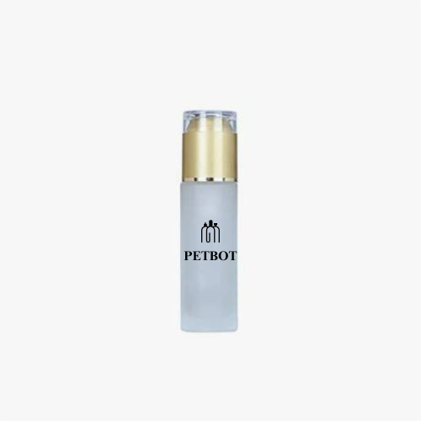

**Skin Care Bottle**

MOQ:

For **stock** plastic bottles, the MOQ is 10,000 pieces.  
For **custom** requirements, please refer to the following MOQ：

* Bottles under 100ml - 100,000 pcs
* Bottles in 100~150ml - 30,000 pcs
* Bottles larger than 150ml - 50,000 pcs

**CUSTOMIZATION:**

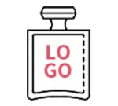

Logo

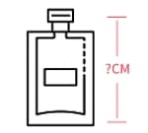

Size

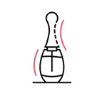

Shape

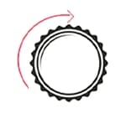

Cap